***EQUIFAX***

CMS Fusion

**SOURCE MATCH**

**DOCUMENTATION**

Table of Contents

1. Source Match 2

1.1 Configure Source Match Parameters 3

1.1.1 Process Name 3

1.1.2 Select input 4

1.1.3 Name and Output Table 4

1.2 Process Flow 5

1.3 Job Status 5

1.3.1 Hit Codes 5

# 1. Source Match

Source match is a Process where we are locating the credit record (CID) for the consumer based on the given Personal Identifiable Information (PII) information like name and address. This will match the list of consumers PII with the corresponding credit file. Source match is also known as **Search Match**.

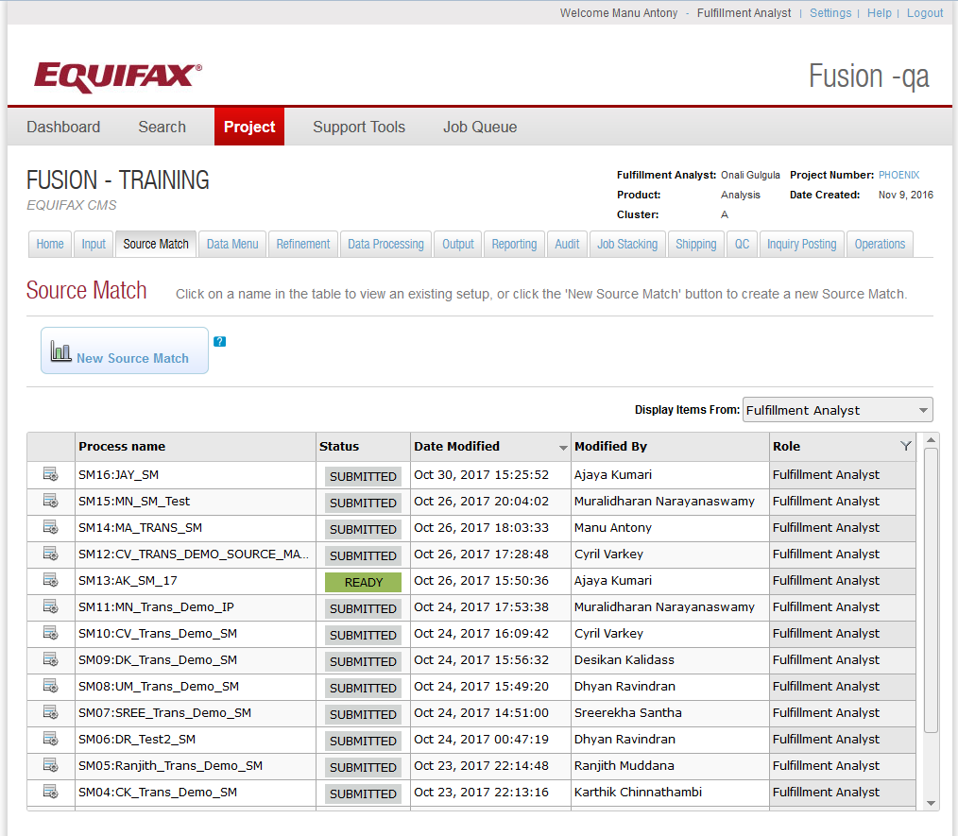

* Process – The Process name used for the process.
* Status – The status of the process created.
* Date Modified – The date on which Process is modified.
* Modified By – Name of the modifier.
* Role – Represents different roles in the application. – Fulfilment Analyst, Programmers.

These will be the role of users who created the process.

## 1.1 Configure Source Match Parameters

By clicking on the New Source Match button we can create a new source match process. This will take the user to the Configure Source Match Parameter Screen. Here the user needs to fill the following information.

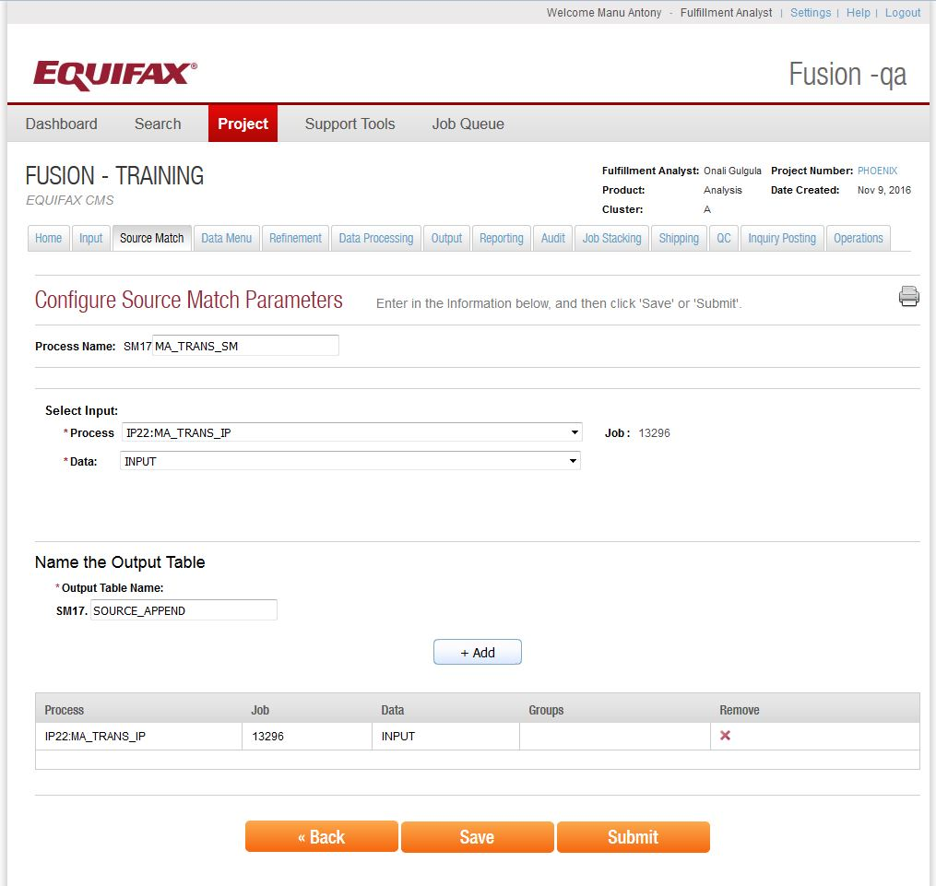

### 1.1.1 Process Name

This field is used to give a name for the source match process. It is prefixed with an auto generated keyword called as **Process Identifier**, which is used to given the unique names for the source match processes, so the user does not need to worry about the uniqueness of the names.

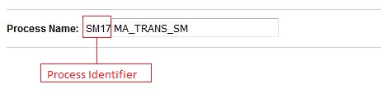

### 1.1.2 Select input

This section is used to select the particular input Process for matching. This should be any process that contains PII information to match against the credit file. User can select the Input process from the process drop down. When the input process is selected its Job ID will be displayed under the Job heading.

*Full Name or First Name and Last name are mandatory for the input process layout; otherwise it will give errors in Source Match Process.*

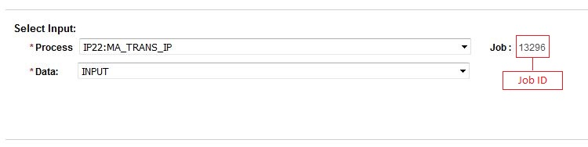

### 1.1.3 Name and Output Table

This section is used to give a name for the output table. Here also the process identifier is used as prefix for the output table name to avoid the naming conflicts.

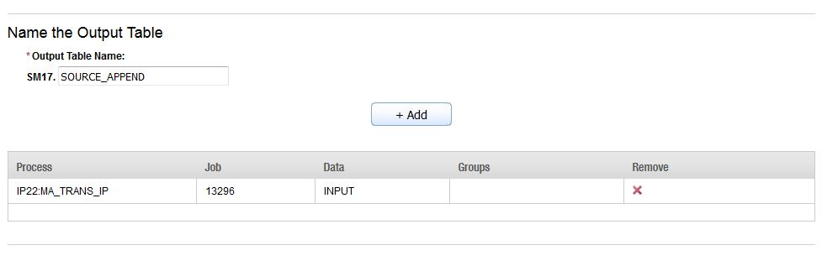

We can also use ***multiple input files*** in source match process by using +Add button. But these files should have ***exact same layout***. This means if we have two input process say P1 and P2. Both should use the same layout. (That means if input process P1 is created with layout L1, Process P2 should be created by reusing the layout L1.)

When we submit a source match process, it will formulate a command with arguments and pass it over to a UNIX server to execute to matching to the credit file. Output of the job will be a source record.

## 1.2 Process Flow

* Export the File to match
* Create and Execute the command in UNIX
* Matching
* Output

## 1.3 Job Status

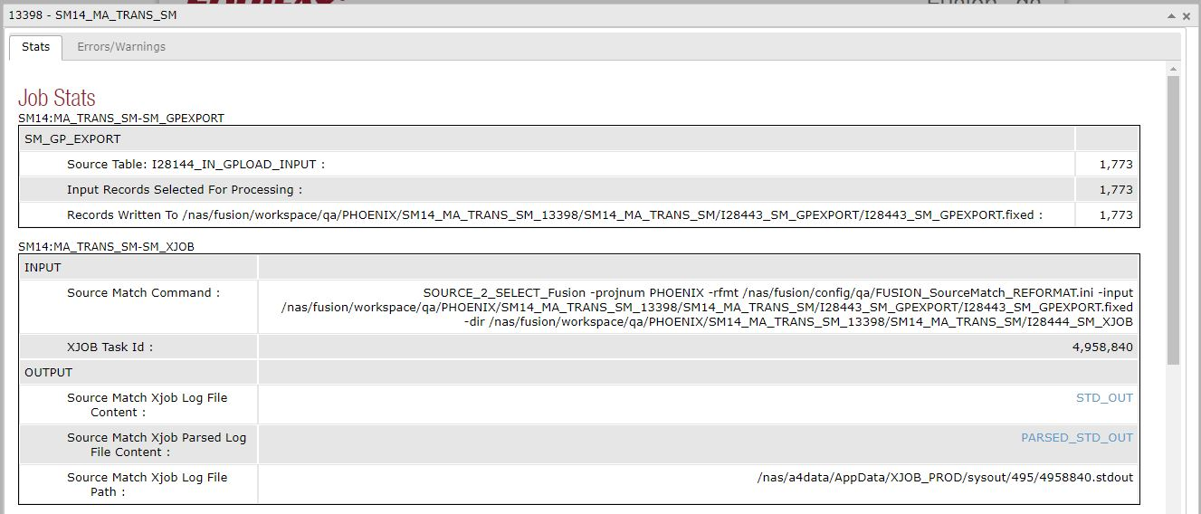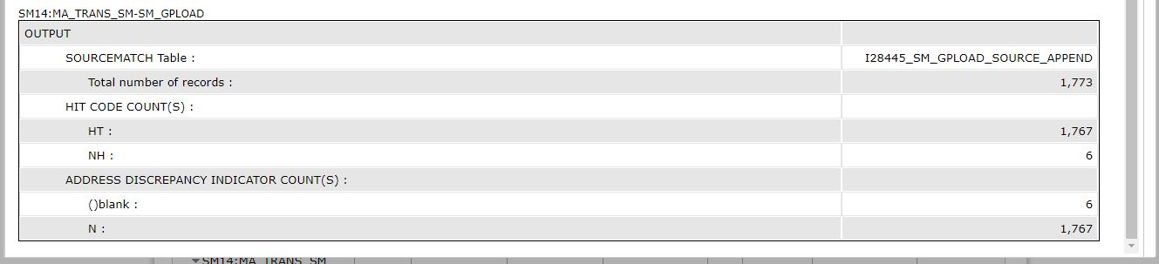

### 1.3.1 Hit Codes

If the process is able to find out the CID for the given data then we can call it as a ***HIT*** otherwise it will be referred as ***NO HIT***. Below table will list some possible hit codes in source match.

|  |  |
| --- | --- |
| Code | Description |
| HT | Got the CID for the given information |
| NH | Cannot find the CID against the given information |
| F1 | Format Reject – Based on Name |
| F2 | Format Reject – Based on Address |